## Solution to exercise 02: Making a medical questionnaire

* Creating, naming, and saving the project:

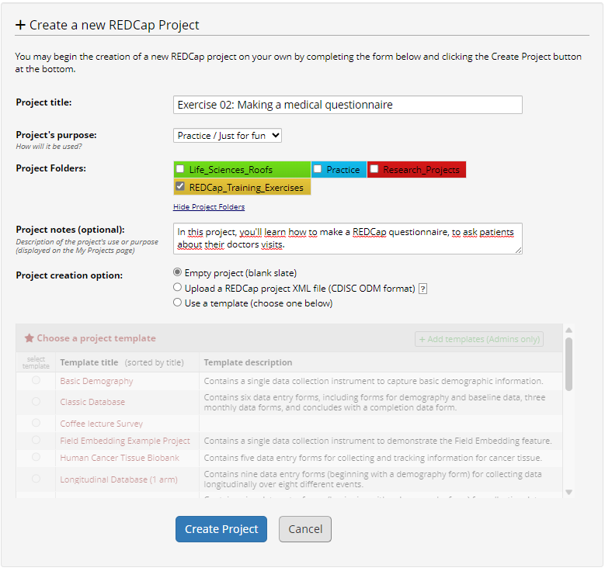

* Change the main project settings:

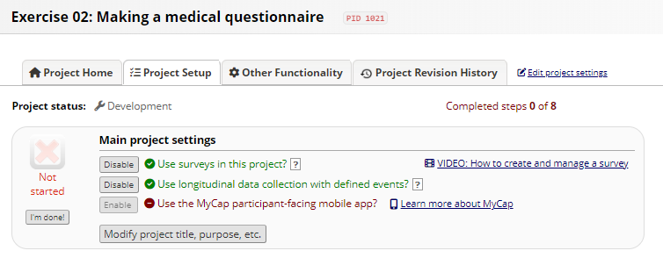

* Mark project settings as completed:

